**Day 1 - AWS - Cloud Computing & IAM**

Create a windows Vm machine in AWS and connect with RDP open CMD in windows share the about system info.

**Solution:-**

Creating a Windows Virtual Machine(named as ” My_Server”) in AWS

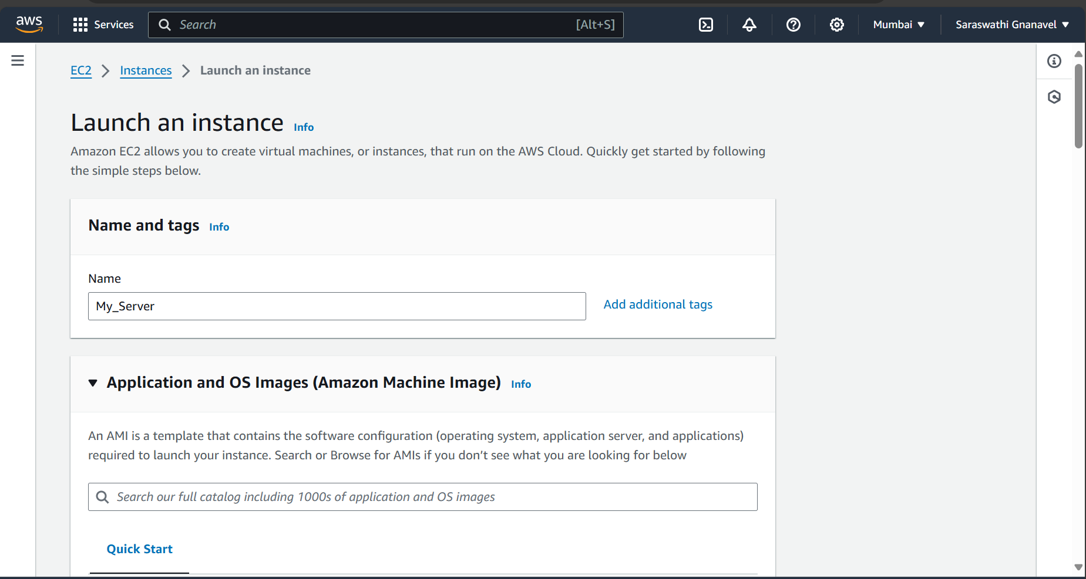

Selecting Windows Operating System

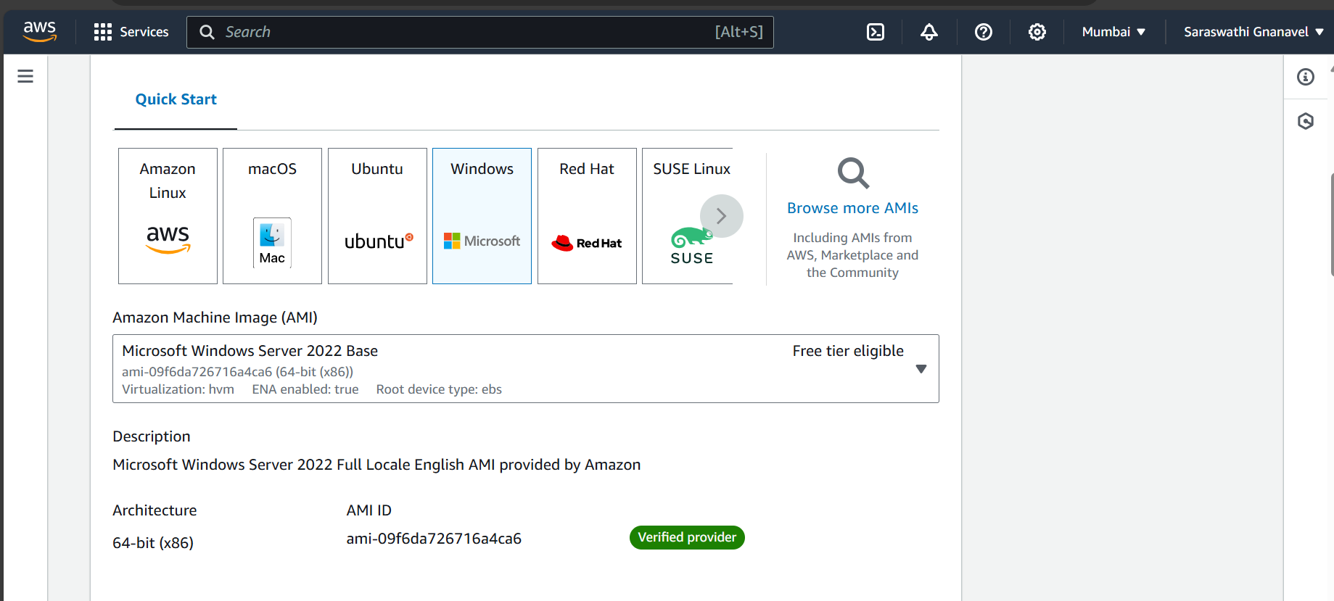

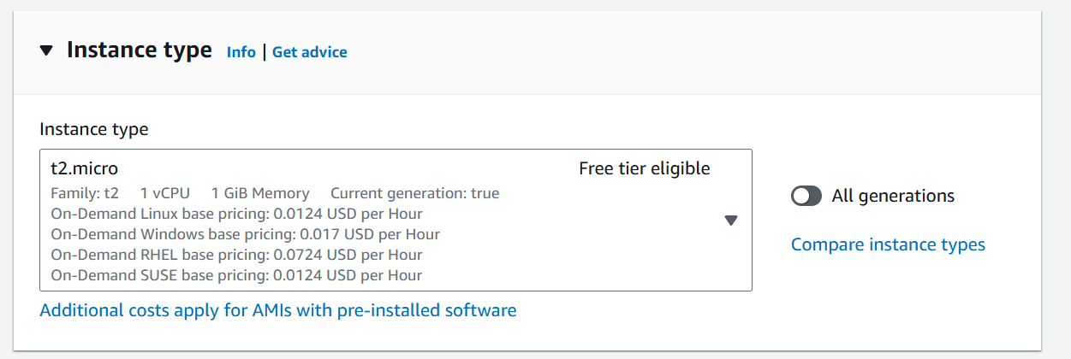

Generating a Key pair to connect with the instance

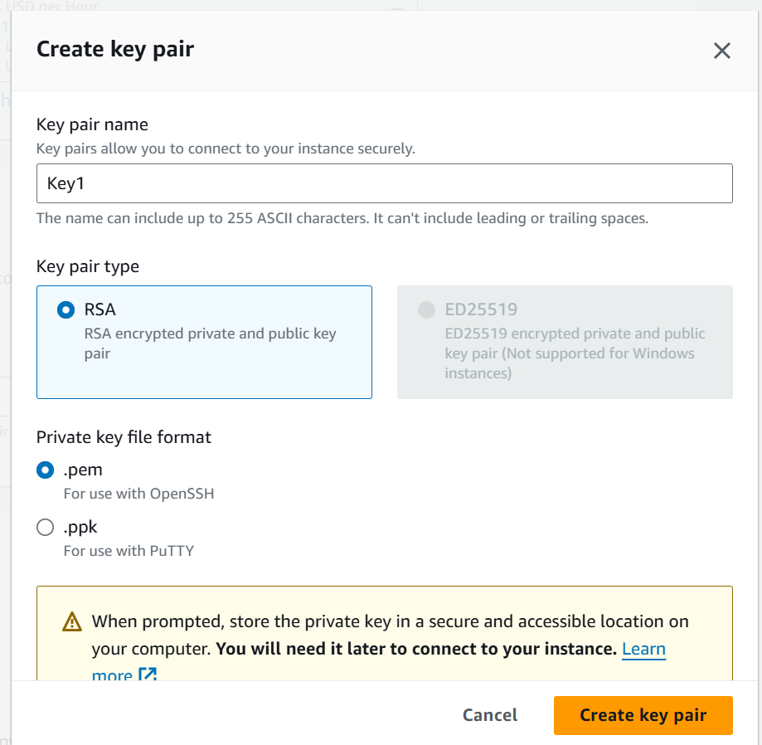

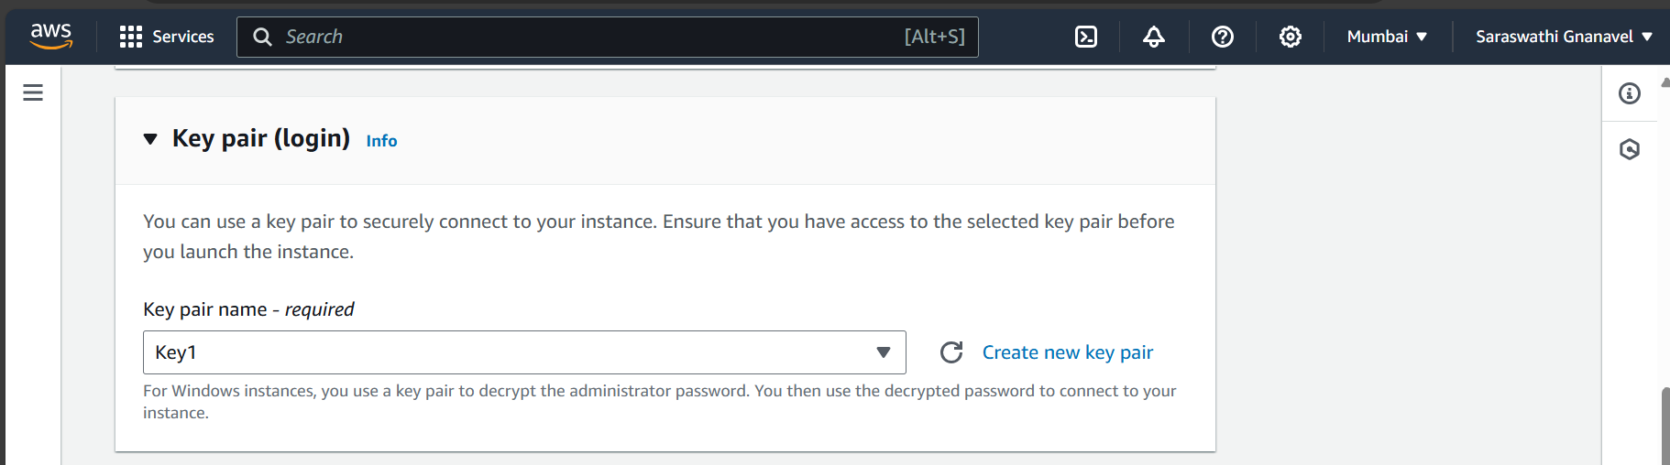

Enabled RDP Traffic in-order to connect with Remote Desktop

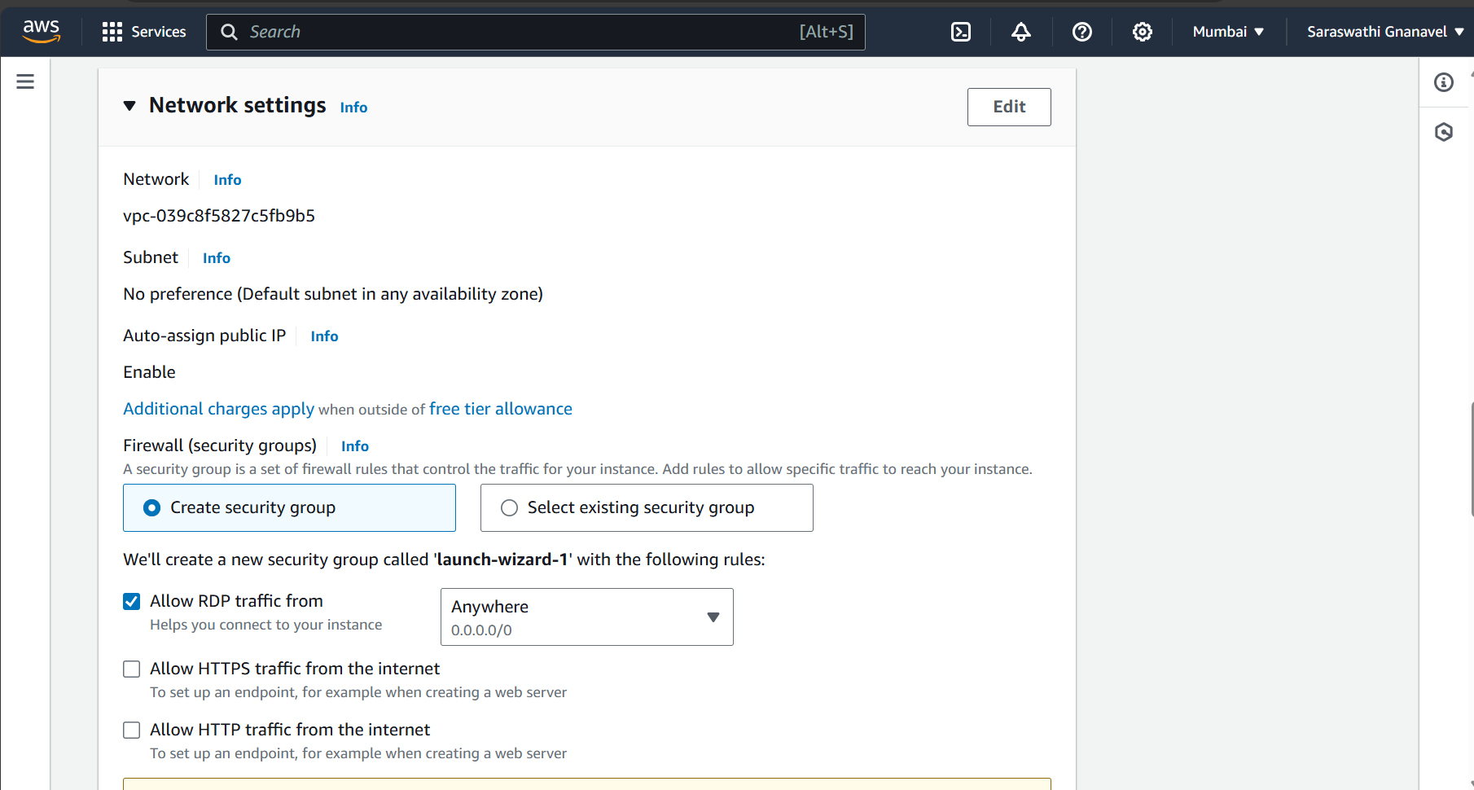

Instance has been created successfully

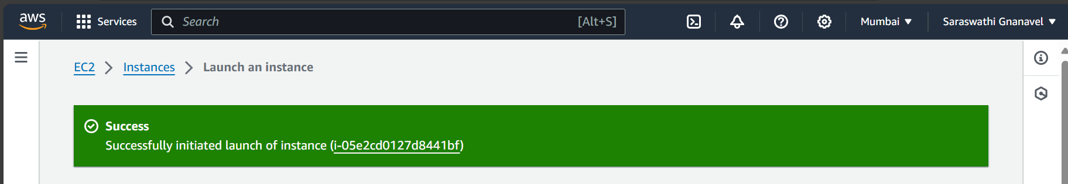

Running the Instance also copied the Public IP Address to run RDP

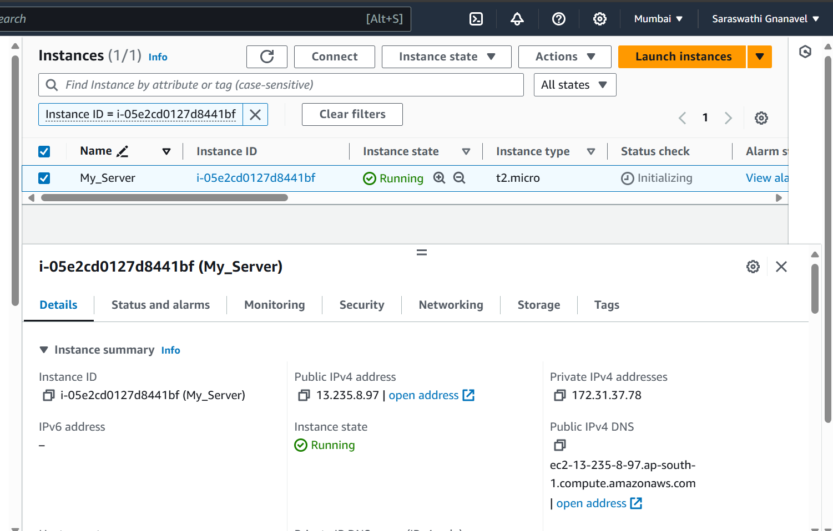

Trying to connect with RDP

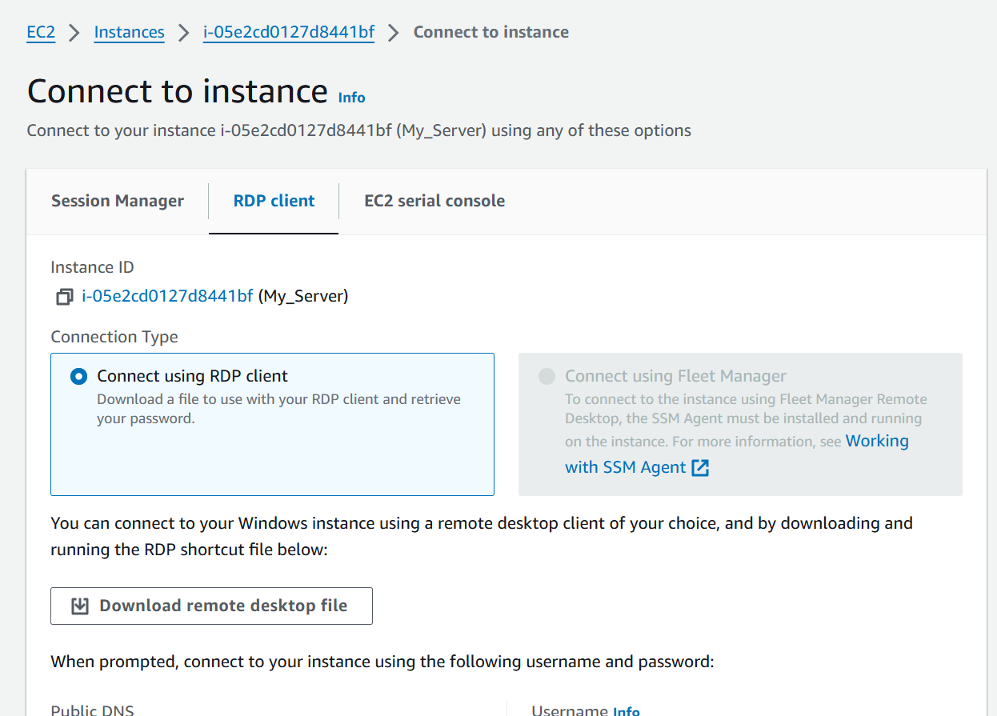

Decrypting Password to access RDP

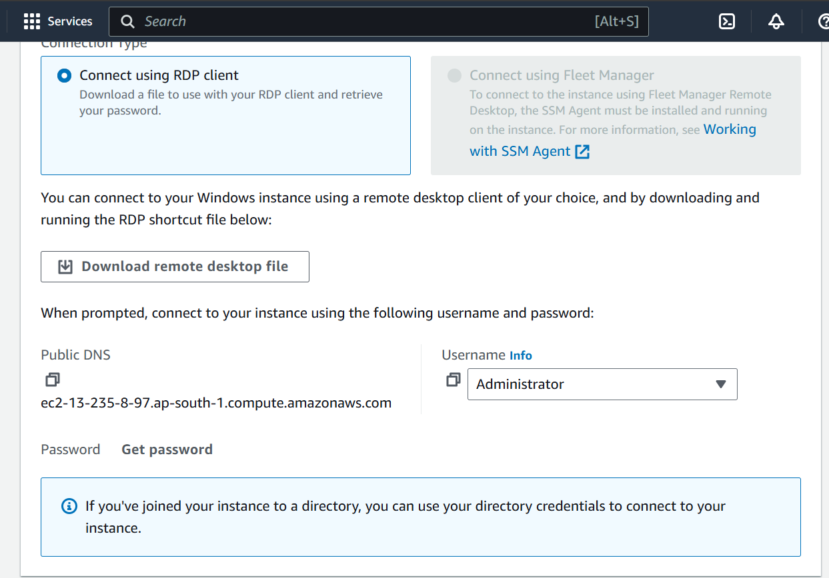

Using Key1.pem keypair file to decrypt the Password

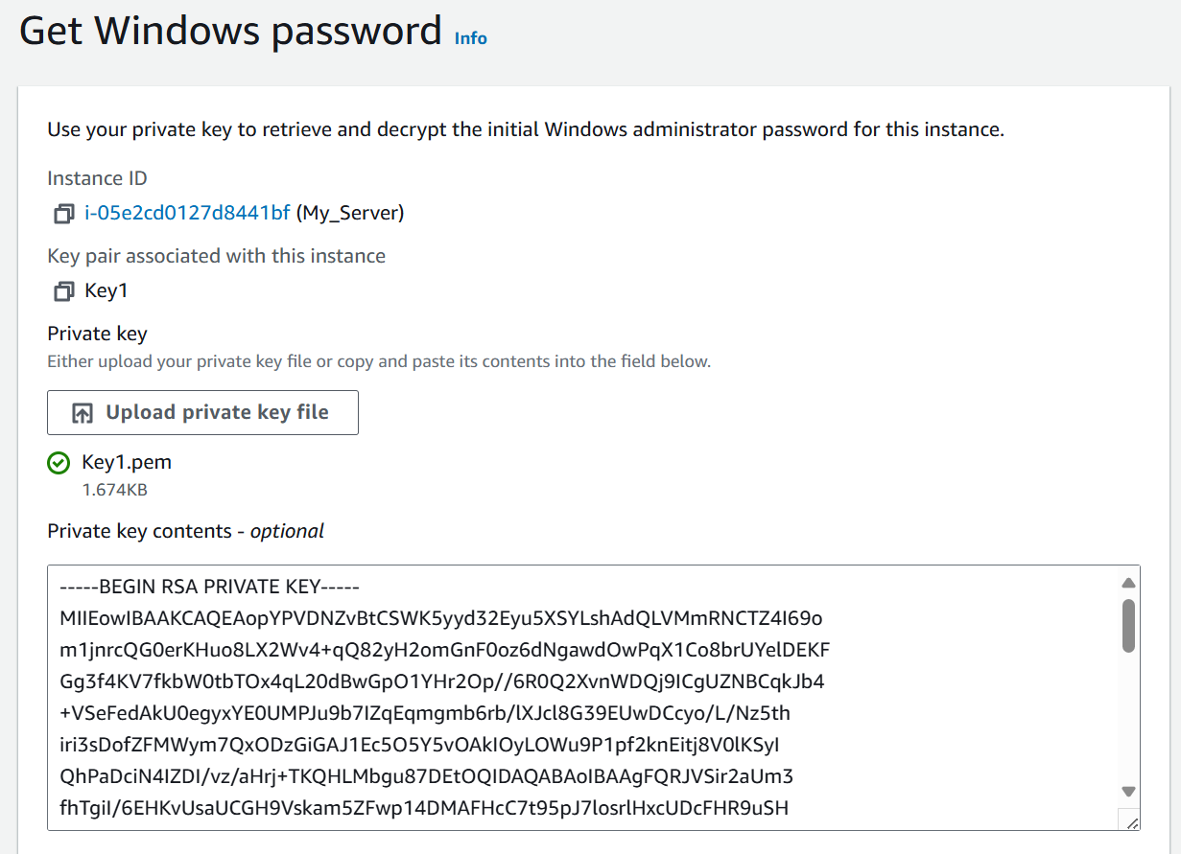

Password has been Decrypted(3)QQ;xKJjDLQ4k;)CU@Qw5;l-Mq9DTe&)

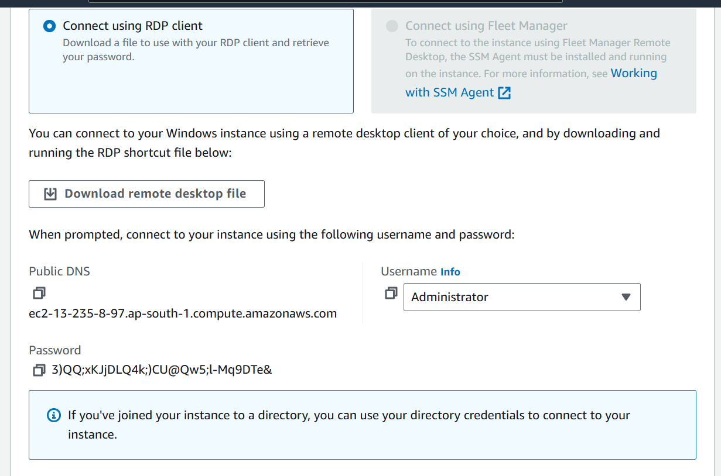

Connecting Remote Desktop via Public address of our Instance

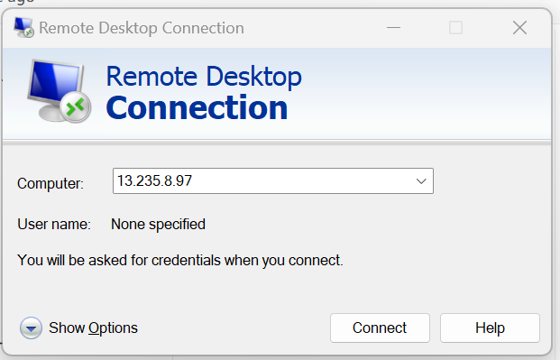

Provided Username and Password(which was Decrypted)

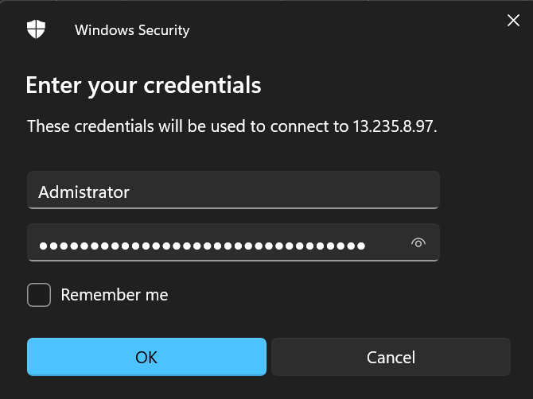

Connecting with Remote Desktop

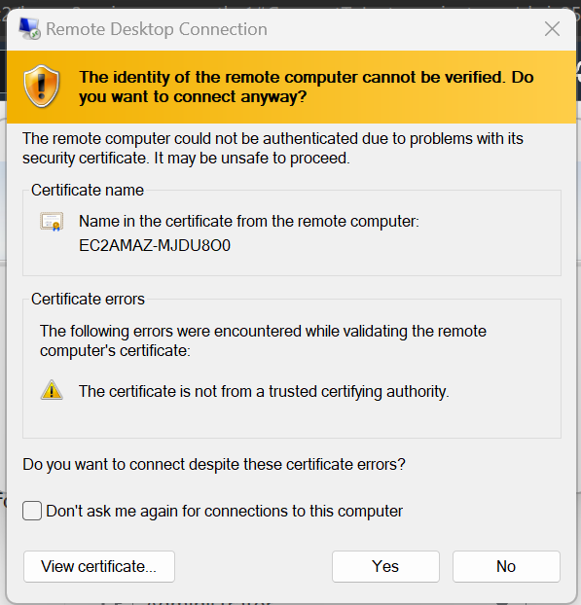

connected with RDP

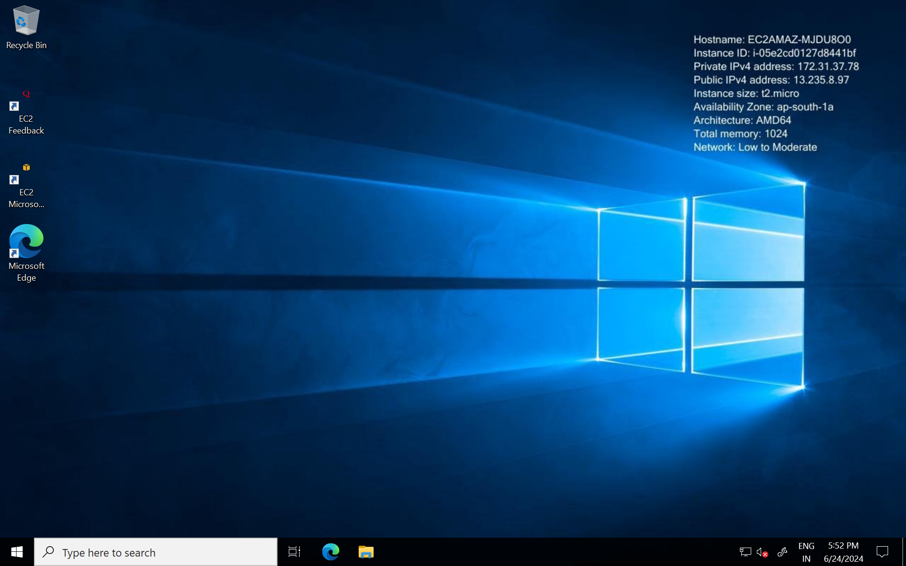

Using CMD prompt in windows to share the system info

